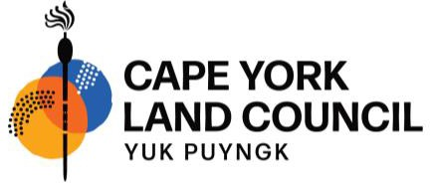
ICN 1163 | ABN 22 965 382 705

NOTICE OF MEETING FOR THE
EASTERN KUKU YALANJI NATIVE TITLE GROUP
Cape York United # 1 Native Title Claim (QUD673/2014)

Thursday 20 February 2025

WUJAL WUJAL
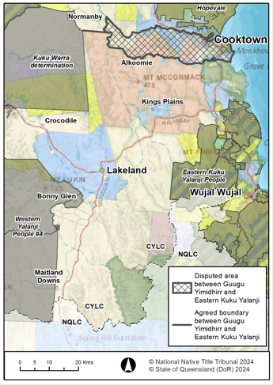
This notice is to advise that the Applicant in the Cape York United #1 (CYU#1) Claim will convene an information, consultation and decision-making meeting on Thursday 20 February 2025 in Wujal Wujal for all members of the Eastern Kuku Yalanji Native Title Group. Cape York Land Council (CYLC) will facilitate the meeting. Please note that this meeting has been rescheduled from Tuesday 10 December 2024. Details of the meeting are as follows:
Eastern Kuku Yalanji Native Title Group
Date: Thursday 20 February 2025
Time: 10am – 3:00pm
Venue: Wujal Wujal Recreation Centre
91 Kotzur Street, Wujal Wujal

Who is invited to attend the meeting?
All members of the Eastern Kuku Yalanji Native Title Group are welcome to attend the meeting.
Purpose of Meeting
On 11 November 2024, a meeting of the Eastern Kuku Yalanji Native Title Group was held to discuss the boundary of Eastern Kuku Yalanji country within the “Endeavour River Disputed Area”, being the area within the CYU#1 Claim Area between the Annan River and Endeavour River, and east to the Normanby River (the cross hachured area shown on the map to the right). This disputed area has been removed from the Court’s case management timetable for proposed native title determinations for the Eastern Kuku Yalanji and Guugu Yimidhirr Native Title Groups, and will proceed under a separate dispute resolution plan that is yet to be prepared by the CYU#1 Applicant.
At the 11 November 2024 meeting, Eastern Kuku Yalanji People requested that before proceeding to a dispute resolution plan, a further meeting of the group be facilitated to consider the available evidence in relation to the Endeavour River Disputed Area and receive expert opinion and advice from the advisors of the CYU#1 Applicant.
The purpose of the meeting on 20 February 2025 is to:
- invite the expert anthropologists to provide an overview of the available evidence in relation to native title connection to the Endeavour River Disputed Area;
- invite the expert genealogist to discuss the available evidence in relation to the apical ancestors from who those Eastern Kuku Yalanji People who claim connection to the Endeavour River Disputed Area are descended;
- receive legal advice about native title matters from the legal advisors of the CYU#1 Applicant; and
- if appropriate, make decision(s) about Eastern Kuku Yalanji native title rights within the Endeavour River Disputed Area including whether the boundaries of that area should be changed in whole or part.

This is an important decision-making meeting and all members of the Eastern Kuku Yalanji Native Title Group are encouraged to attend. The legal representative of the CYU#1 Applicant will take instructions on the group and boundary descriptions for the Eastern Kuku Yalanji by way of resolution. In accordance with the applicable Federal Court timetable, the group and boundary descriptions must be decided by Eastern Kuku Yalanji and provided to the State for final agreement.

Attendance and Video-Conferencing
For travel assistance or to confirm attendance, please contact Lee Ann Miller by Thursday 13 February 2025 on free call number 1800 623 548 or by email lmiller@cylc.org.au. Note that there is limited funding available for travel assistance. If you have queries about this meeting, please contact Michelle Cioffi on 0408 408 017. Video-conferencing facilities will also be made available at the meeting. If you would like CYLC to arrange a video-conference from your location into the meeting, whether you live at the location of the meeting or elsewhere, please contact CYLC. It is important to provide every opportunity for persons entitled to attend the meeting.

